**MILESTONE 1 – DESIGN CLASS DIAGRAMS – JULIAN PINTO (30045167) – ANTONIO SANTOS (30046544)**

# High Level Class Diagram – Frontend and Backend

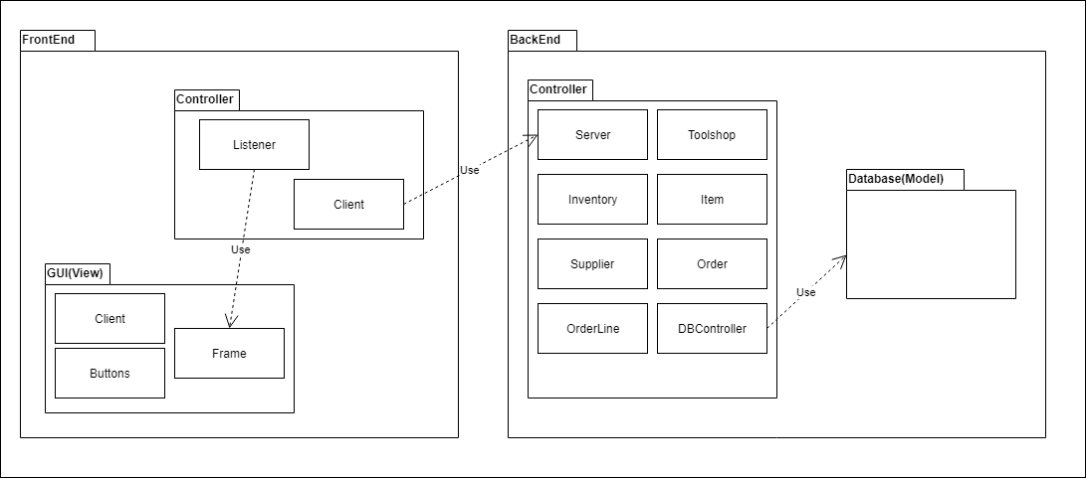

# Detailed Frontend Diagram

# Detailed Backend Diagram

